促進親子關係小貼士 助孩子面對人生挑戰

撰文：資深幼兒教育顧問莫萊茵小姐

https://www.shutterstock.com/zh/image-photo/attractive-asian-family-happy-smile-little-1723153423

近年弒父弒母的新聞屢見不鮮，筆者在綜合節目中聽到一位中年女兒埋怨母親的心聲，都令筆者感到十分可悲，不禁心想：「生嚿叉燒好過生佢。」生命的奇蹟本來喜悅無限，可是他們卻變成了父母與子女兩代人生的痛苦悲劇。

這些悲劇和敗家子女的故事，在現代社會中開始湧現，根本原因在於親子關係、家庭成員血脈相連的親情和個人在家庭責任的角色上，出現嚴重偏差。結果令怨恨及推卸出現，更無力對抗負面意識，甚至想透過傷害他人而令自己得到解脫。

孩子走上正路 依靠父母灌輸價值觀
父母雖然心痛，但始終沒有辦法回到過去，重新與子女建立親愛情感，修補重視家人血脈相連關係的價值。人亦無選擇父母的機會，只有珍惜緣分。但是，父母可以把握現在，讓孩子知道你是世上最無私的，好好讓他們感受到父母的溫柔和溫暖。

因為我們不知道何時不在孩子身旁，能夠幫助他判斷的、預防孩子行差踏錯、抵禦負面誘惑的，只有父母平日教導他的價值觀和親子關係！為人子女的，要明白不論家庭生活順逆，都是一種恩賜與鍛煉。人在鍛煉中會變得更精壯，是無比珍貴的成長元素！

當我們看到其他家庭和別人人生的悲劇，警剔我們堅決不走他們同樣的路。同時，若父母了解到當自己離世時，就只有一生的智慧、文化和為子女建立了的品格留給子孫。此刻，家長們對子女有甚麼期望呢？筆者願：「只要當一個好人！」而故事教育就是帶給孩子重要的價值觀和交流、建立親子關係的好途徑！

親情可貴 自小累積親密感
父母必須努力從孩子小時候便累積親密感，以下的媽媽能把握孩子對安全感的需要，示範了建立親密感和同理心的重點：

一天， 2 歲的寶寶突然舉起雙手，腳指蹺起，似乎非常渴望有成人的愛護。我們一般說這行為是「撒嬌」，可是爸爸說：「抱BB啊，好吧，先站好比爸爸看。」此刻，寶寶轉向媽媽身旁，再次舉起雙手，腳指蹺起，露出非常渴望呵護的神情，媽媽便立即把寶寶抱入懷，並說出感人和無私的說話讓爸爸知道：「啊，爸爸媽媽的愛是不需要小寶寶乞求的、愛是任何時候都有的，而且我們沒有太多日子能夠如此親密，就讓小寶寶感受我們的愛吧。」以上的故事讓大家細味為人父母之價值、角色和回應吧！

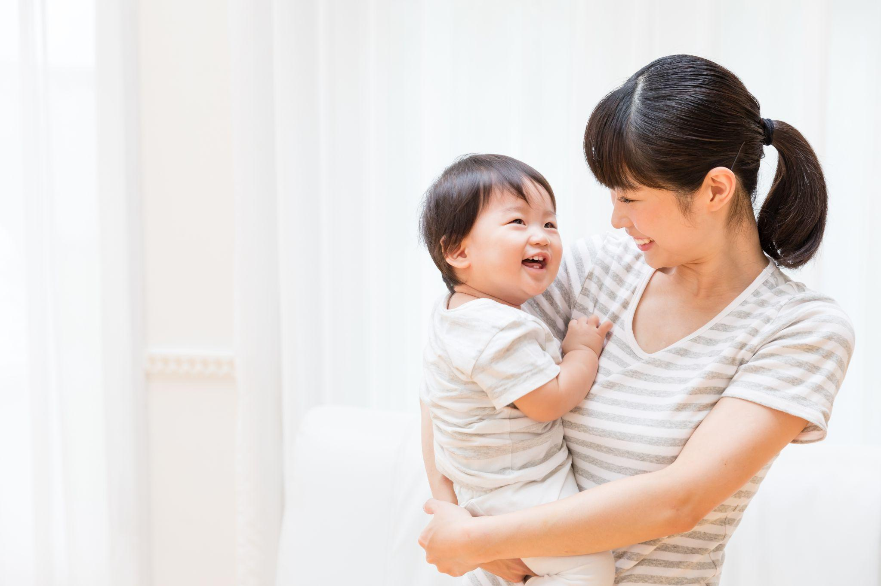
https://www.shutterstock.com/zh/image-photo/portrait-asian-mother-baby-lifestyle-image-521547586

另外，筆者有數個促進親子關係和故事教育的小貼士跟大家分享：

1. 讓孩子從你的行為中了解你對事情的價值觀、觀點和回應方法
2. 不要讓孩子害怕你叫他，或使他感到煩擾，包括每次只有考驗或完成你指派的任務
3. 家長式訓示方法只適用於危及健康或生命的情況，否則只需要提出預告後果，讓孩子碰釘後，以平常反應回應孩子的憤怒和痛楚
4. 當孩子主動告訴事情時，要多引發他說出觀點，提出假設代入另一個角色，分析情感和想法，以增加同理心
5. 多製造共同學習機會和話題，讓你與孩子有相同感受及經驗
6. 如孩子投入在故事中的回答有價值觀的偏差，如暴力、復仇等傾向，需要表明爸媽為此而感到傷心，然後要引導孩子想出合情理的解決方法或放下事情的好處

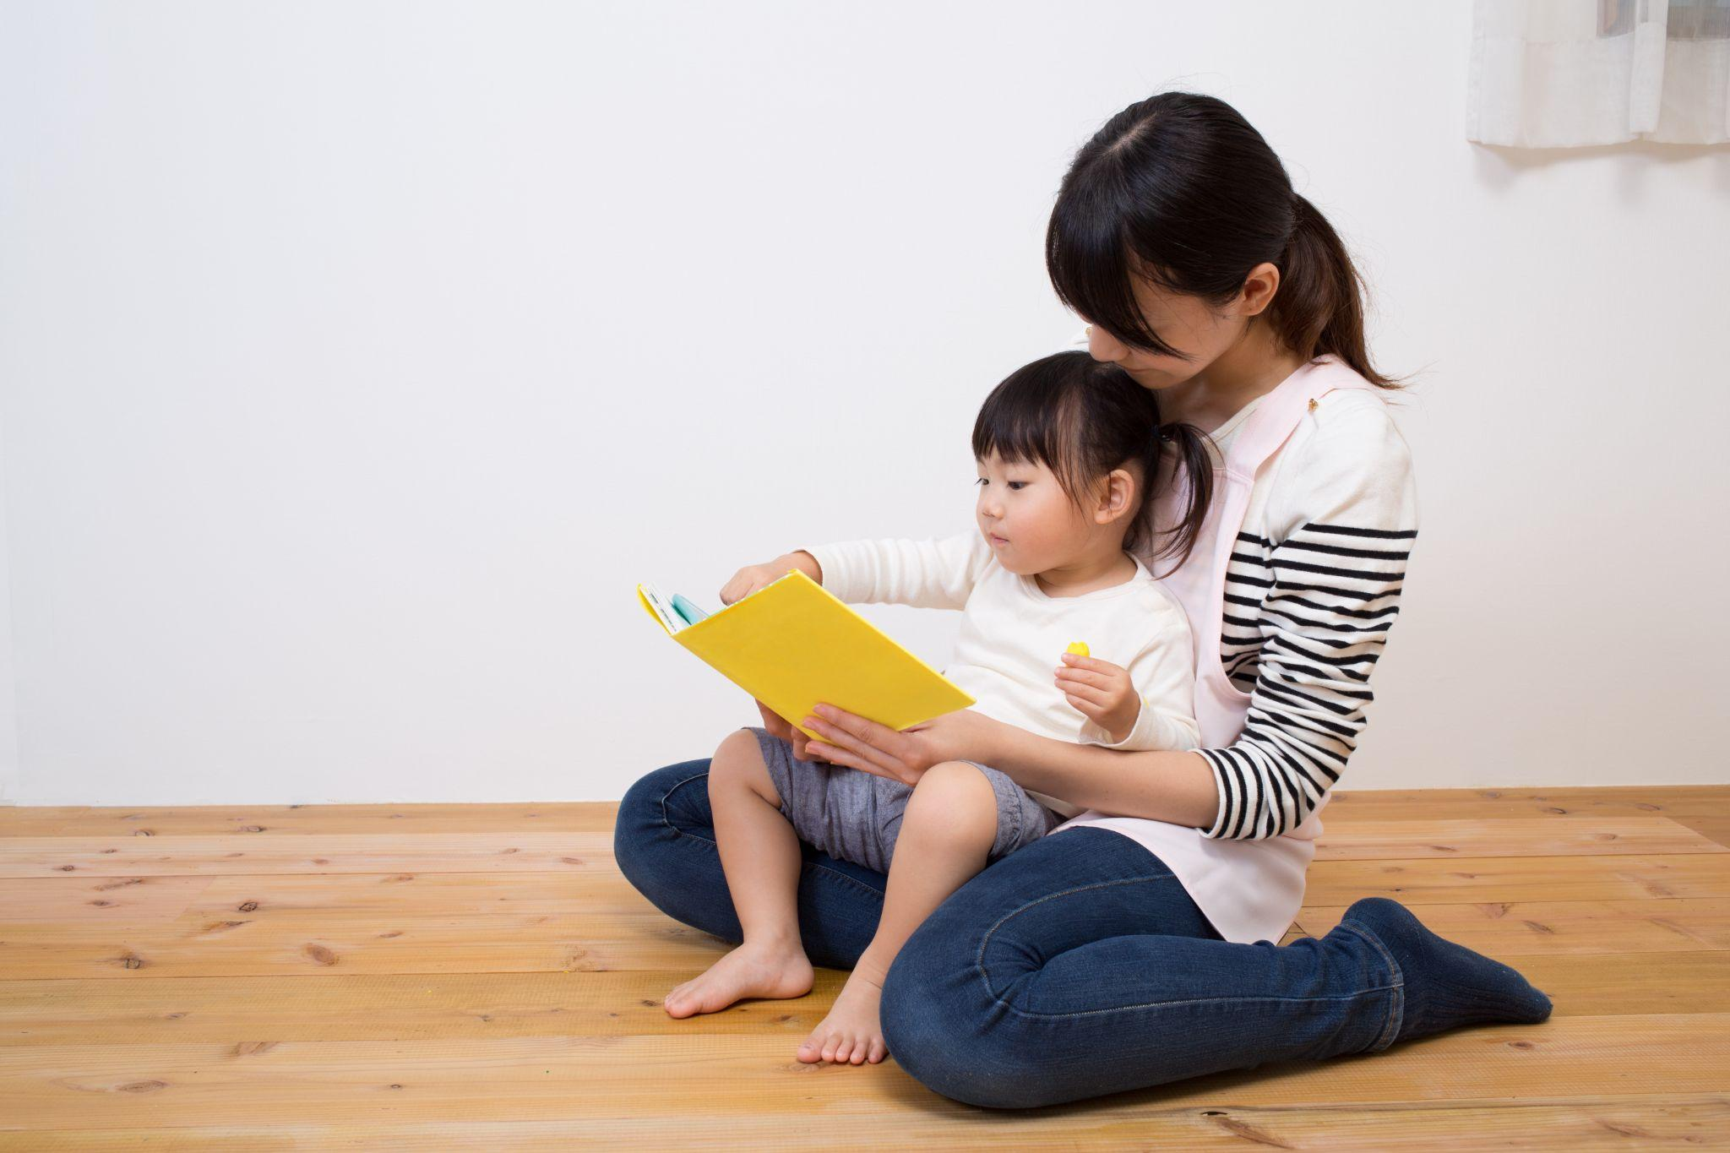
https://www.shutterstock.com/zh/image-photo/kid-enjoy-story-telling-346981469

總結而言，每人都有感情和心理滿足的需要，要讓孩子從感情與認知中平衡成長，父母必須修身方能齊家，父母本身要有判辨的能力，並懂得孩子整個人生的價值：是福樂與貢獻，孩子才能在你的身教和言教下，承傳及散播愛的使命。

